

|  |  |  |  |  |  |  |  |  |
| --- | --- | --- | --- | --- | --- | --- | --- | --- |
|  | | | | | | | | |
|  | | First Milestone, First Revision | | | | |  | |
|  |  | | | | | | |  |
|  | | | |  |  | | | |
|  | | | |  |  | | | |
|  | | | | Date: 15/11/2022—Course: App DevelopmentStudent: Eyal KotlikTeacher: Hila Goren |  | | | |
|  | | |  | | |  | | |



|  |  |  |  |  |  |  |  |  |
| --- | --- | --- | --- | --- | --- | --- | --- | --- |
|  |  | | |  |  | | |  |
|  | Overview | | | | | | |  |
|  |  | | |  |  | | |  |
|  |  | |  | | |  | |  |
|  |  |  | As of now, I have processed the primary data required for the app’s functions, excluding any special abilities as they are no longer considered necessary for the app. In addition, I have created the basic implementation of the classes which the application is going to use in its calculations.  The data was processed using the “pandas” and “math” python libraries. | | |  |  |  |
|  | | | | |
|  |  |  |  |
|  |  |



|  |  |  |  |  |  |  |  |  |
| --- | --- | --- | --- | --- | --- | --- | --- | --- |
|  | |  |  | | |  |  | |
|  | | Specifications | | | | |  | |
|  | |  |  | | |  |  | |
|  | Python file and the Data The python file takes raw data downloaded from the website <https://wahapedia.ru> which hosts the rules for Warhammer 40k – the game whose army building this app seeks to simplify. Then the raw data if transformed into a more useful formant for a computer.  The data itself is currently organized into several CSV files (“|” is the delimiter), these files are sorted and filtered so most of the unnecessary information is removed so it becomes somewhat possible to navigate them.  Additionally, I created the Model.py & Ability.py to present the basics of the classes which the app is expected to utilize as well as to demonstrate that the processed data is usable by the app. | | | | | | |  |
|  | Future Goals | | |  |  | | |  |
|  | I have two distinct goals for the next milestone, the first being transferring the prototype python files into an android app. This is my primary goal for the second milestone and will include everything from downloading and processing the data to displaying it in the app. | | |  | The Second goal is to research the possible methods to compute the probable outcomes of the models’ attacks and their probability distributions. For the second milestone, I intended to implement a method for calculating the average outcome of an attack as well as its standard deviation | | |  |

|  |  |  |  |  |  |  |
| --- | --- | --- | --- | --- | --- | --- |
|  | Data Diagram | | | | |  |
|  | |  |  |  |  | |
|  |  | | | | |  |

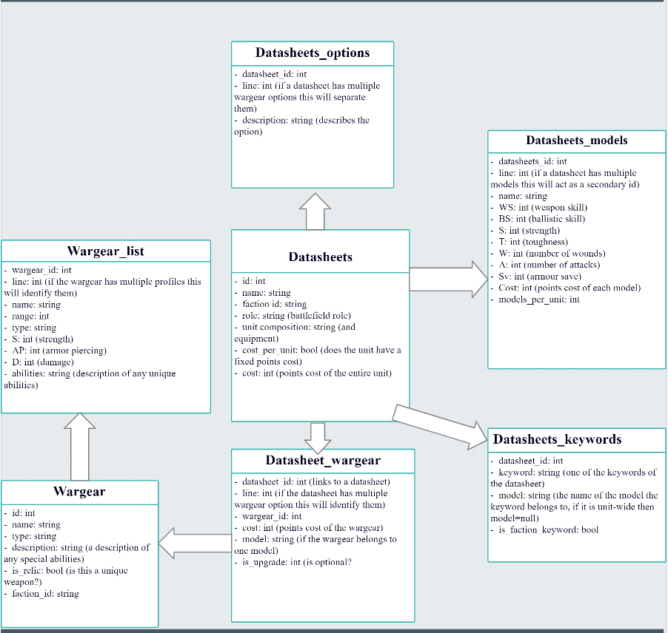

|  |  |  |  |  |  |  |
| --- | --- | --- | --- | --- | --- | --- |
|  | Class Structure | | | | |  |
|  | |  |  |  |  | |
|  |  | | | | |  |

# 

# Bibliography and Tools

* <https://www.w3schools.com>
* <https://docs.python.org/3/>
* <https://www.geeksforgeeks.org/>
* <https://stackoverflow.com/>
* <https://wahapedia.ru/>
* <https://app.creately.com/>
* <https://github.com/>
* <https://app.creately.com/>